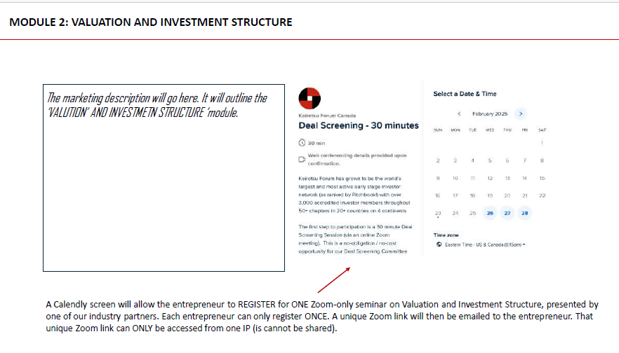
Query: The user enters their name or email to generate a Zoom link, and the link is then sent to their email. But my question is—where do we get the list of users? Are we supposed to send the Zoom link to all users or just the one who submitted the form? I'm a bit confused.

We will have entrepreneurs sign up for our Entrepreneur Academy. Two ways to do this:
- We have cohorts. For example, we have x number of slots available for the month of April. They all move through the system at their own pace.
- Each entrepreneur who signs up can then schedule their module. We need to ensure that the system keeps track of their enrollment/participation.

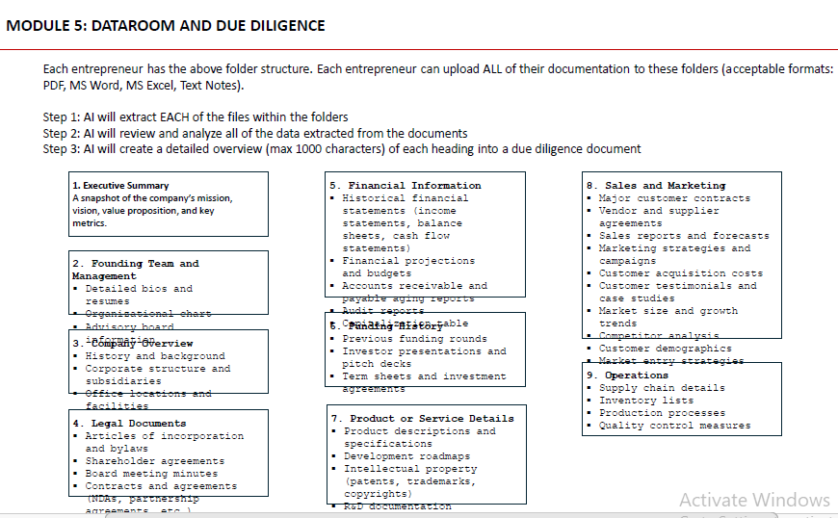

This task clear but confirmation: (For example like this)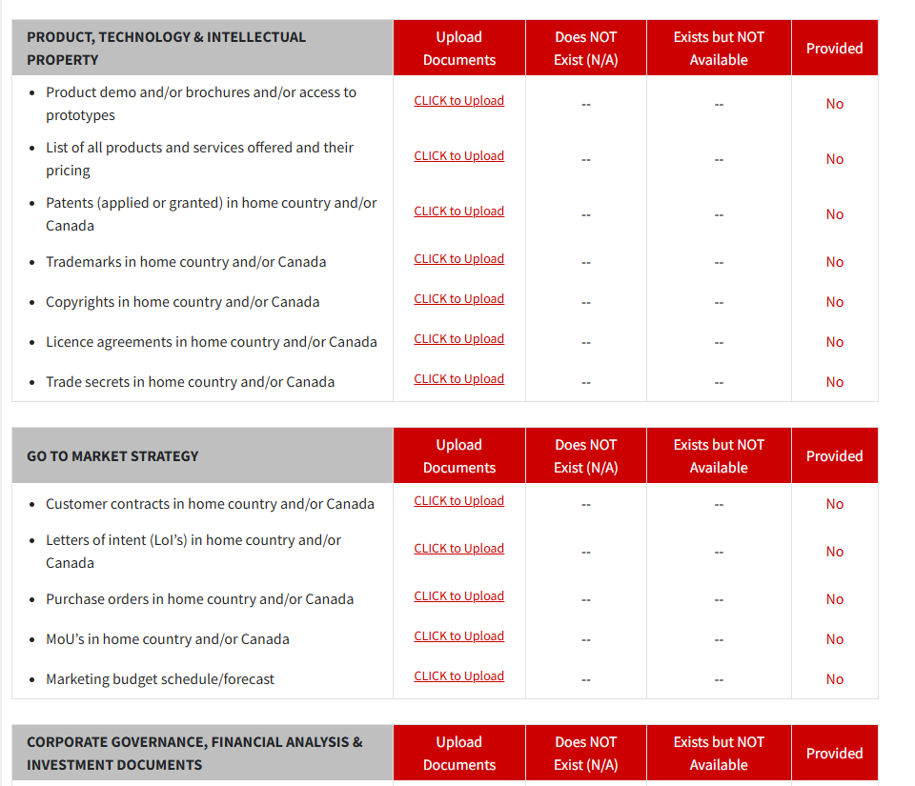ion:
Exactly like this. Please add ‘ADDITIONAL DOCUMENTS’ at the end of each category. I may need to add descriptions for each category so that the companies know exactly what the expectations are for each category. Is there a way for entrepreneurs to ‘minimize’ the categories so that they can see ONLY the headers? They can then maximize each category as they move through the uploads.

Query: Module related:
Please explain for user subscription regarding module and video view regarding
Each entrepreneur will be able to view the video by clicking on it. They will have THREE chances to view the video and the videos cannot be downloaded or copied (this is our proprietary content). Once they view the videos, the module will be finished (non-accessable).

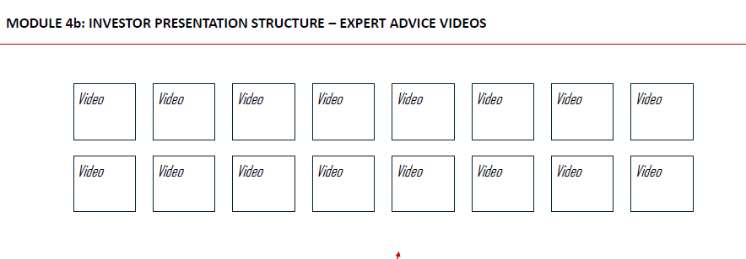

- Language independent. We will market this in China, Hong Kong, Thailand, India(?), etc.
Query: Please provide the country name for the language, because each country's language is defined separately in the code.
At this point, we only have the modules in ENGLISH. Once we launch, we will add other languages.
- I should be able to charge independently for each module or charge one price—multiple currencies.
Query: I have five modules, and I believe modules 1 to 4 are chargeable. Please explain how each module is charged and what the usage limits are.

For example, when we launch in Hong Kong / China, will have two ways to reach entrepreneurs:
- Via distributors (incubators, universities, etc.…). They will have cohorts register for the Entrepreneur Academy. We may have 2/5 modules available for them, or we can have all of the modules available for them.
- For North American companies, we ‘may’ ONLY have the due diligence (data room) module available.
This is why I need to have each module independent from each other, in case we need to engage with distributors or entrepreneurs separately.
Once I review the modules, I will most probably have edits/adjustments for you, based on the business models we are preparing.

